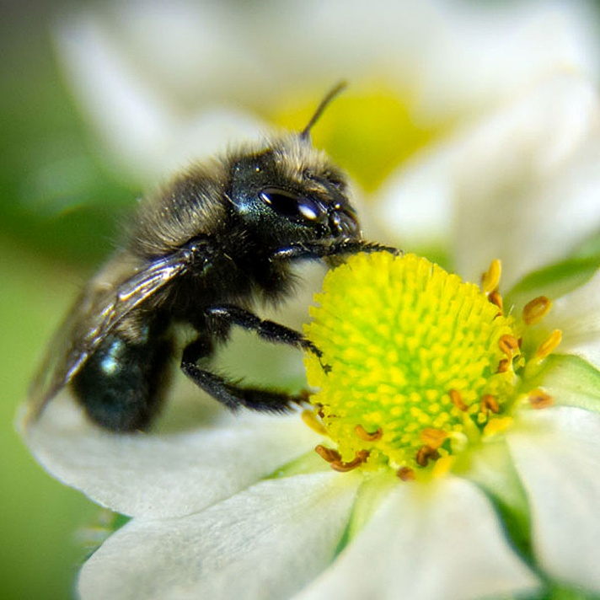

Table of Contents
- Introduction
- Bee Activities for Children
  - Mighty Mason Bee Activity Creating Larva and Pollen
  - Mighty Mason Bee Activity Collecting Pollen
  - Mighty Mason Bee Nesting Hole Activity
  - Create a Large Mason bee Nest
  - Create a Flying Mason bee
- Visual Aides created from harvested materials
  - Mud Caps
  - Pollen balls
- Additional Resources
- Scientific Articles (for facilitators or older participants

Thank you, Amy Hanson,
A teacher in Washington State
for sharing these ideas with so many!

Bee Activities for Children
Introduction
The Mason Bee Activities program introduces young learners to the fascinating world of solitary bees through interactive, hands-on activities. Designed for elementary-aged children, these activities encourage curiosity, creativity, and a deeper understanding of pollinator conservation. Participants will explore the lifecycle of mason bees and learn how they contribute to ecosystems by building nests, collecting pollen, and supporting plant reproduction.
This program is ideal for classrooms, community centers, and outdoor workshops. Safety considerations include adult supervision and age-appropriate materials for all activities.
Time to Complete: 1–1.5 hours
Age Recommendation: Best for Elementary (ages 6–10)
Location: Indoor or Outdoor
Activities:
- Word Search wild bees
- Crossword puzzle
- Letter sort
- Label parts of Flower and Bee

Mighty Mason Bee Activity Creating Larva and Pollen
Have kids create a hands-on display of Larva, pollen, and Nesting hole using tubes and modeling clay. Use a yellow puck of pollen that fits into the cardboard tube nesting hole. Craft the larva from clay.
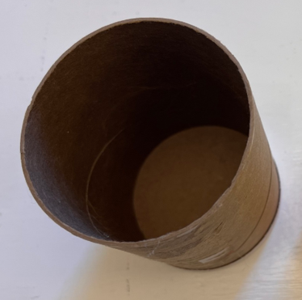

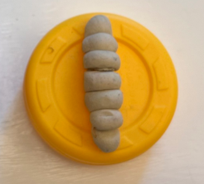

Mighty Mason Bee Activity Collecting Pollen
Items per kit:
- Pom poms of yellow and orange and maybe even some sparkly.
- Two Velcro covered mitts or game mitts with Velcro.
Have kids toss pom poms to catch or to “race” to see how many of them that they can catch. Discuss how many pollen grains were dropped or mixed up together.
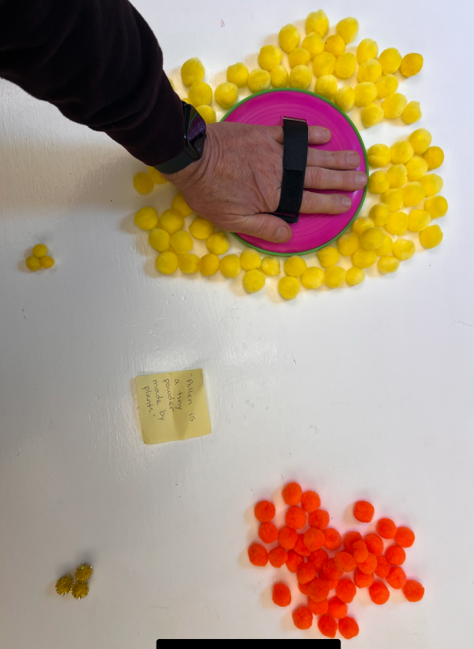
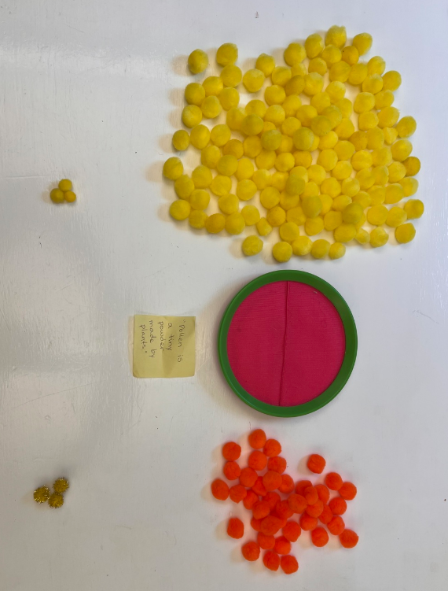
This activity demonstrates how pollen is spread by bees carrying loosely on their hairy bodies.
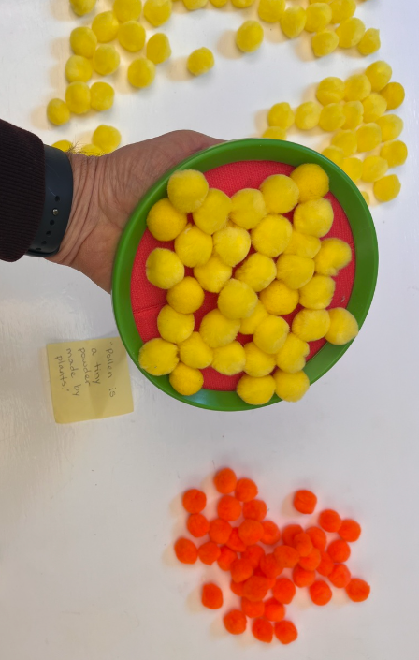
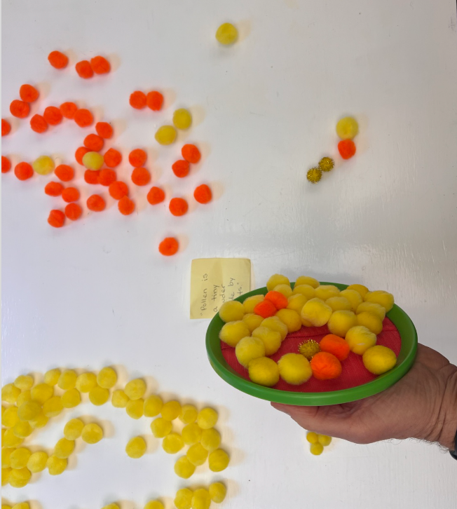

Mighty Mason Bee Nesting Hole Activity
Let's Pretend that YOU are a mason bee with an important job to do. You've found a perfectly sized hole and now you need to build a home for your kids, with separate bedrooms, and plenty to eat. Your kids have some major growth to do while they’re safe at home, and this activity will show them at three different stages in their early life cycle.
Items per kit:
- 1 toilet paper cardboard tube, ~3 yellow pom poms, 3 brown felt squares (2.5 inches)
- 1X two glued together squares to make a thicker square for the outer door.
- Rice, white bean, kidney bean
Instructions:
- Place the tan felt mud in the back of the nesting hole tube.
- Add pile of pom pom “pile of pollen and nectar” for the baby bees to eat.
- Add the grain of rice for the egg
- Use another piece of felt to close the bedroom door.
Next, pack another lunch in the hole for the next baby bee, add egg, and seal the door too. Repeat a third time and then close with an extra thick piece of felt for safety from predators.
Now, if you want, pretend that the babies are older and replace the egg with a hungry larva and a white bean. Finally, pretend that the larva has eaten ass the food and spun into its’ cocoon and replace the pom poms and white bean with a pinto bean cocoon.
WELL DONE! Your hard work means next spring there will be plenty of bees to pollinate important plants that provide food.
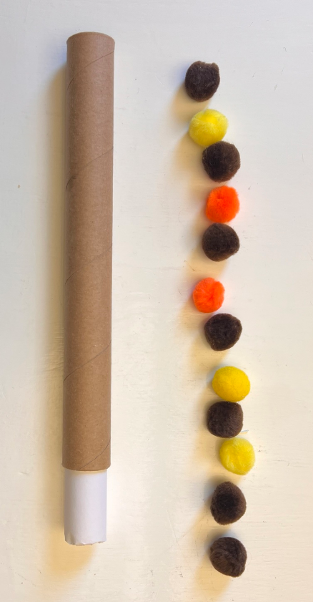

Alternative Nesting for younger children: Create a Large Mason bee Nest
- Brown paper sack with top turned down
- 1 medium-sized Brown paper sack with top turned down
- ~3X a dozen yellow pom poms glued together size of your fist
- 3 brown felt circles (8 inches across)
- 1X two glued together circles to make a thicker circle for the outer door.
- Smaller white rock, medium-sized rock, medium-sized brown rock
Instructions:
- Place the tan felt mud in the back of the nesting hole paper sack.
- Add pile of pompom “pile of pollen and nectar” for the baby bees to eat.
- Add the smaller white rock for the egg
- Use another piece of felt to close the bedroom door.
Next, pack another lunch in the hole for the next baby bee, add an egg, and seal the door too. Repeat a third time and then close with an extra thick piece of felt for safety from predators. Now, if you want, pretend that the babies are older and replace the egg with a hungry larva and a white bean. Finally, pretend that the larva has eaten ass the food and spun into its’ cocoon and replace the pom poms and white bean with a pinto bean cocoon.
WELL DONE! Your hard work means next spring there will be plenty of bees to pollinate important plants that provide food.
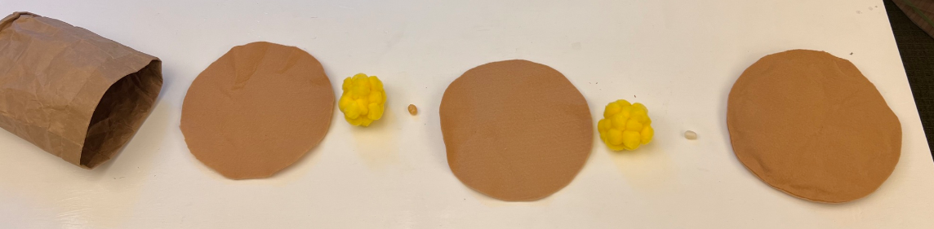
Nesting Material
Mud
Bee Egg
Pollen & Nectar
Mud
Thick Mud End Cap
Bee Egg

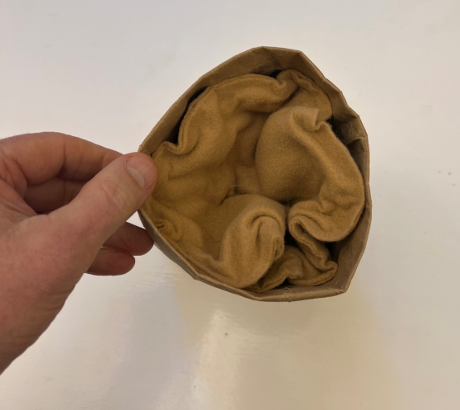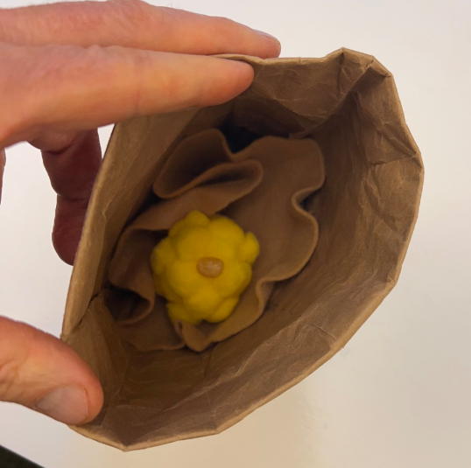

Alternative Nesting for younger children: Create a Flying Mason bee
Glue heart shaped fabric to glitter clothes pin to create a Mason bee
It can carry Pollen pom poms
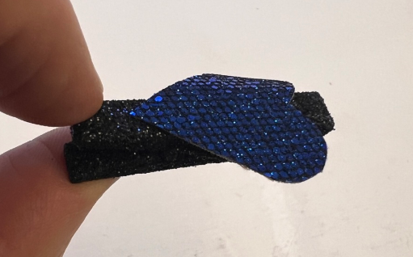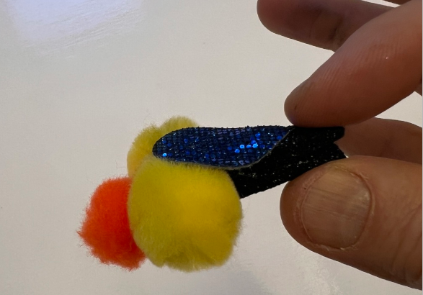
- Visual Aides are created from harvested materials. This gives a representation of the size and work that the Mason bee does to protect and provide for her eggs.
  - Mud Caps
  - Pollen balls
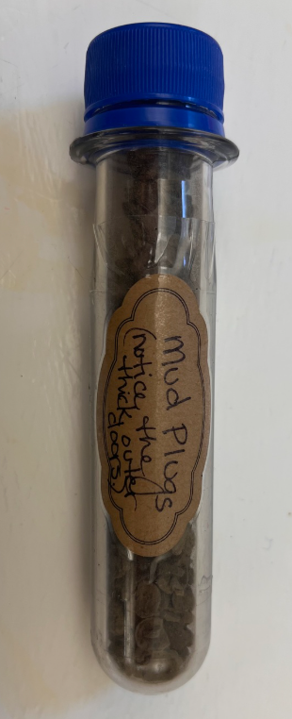
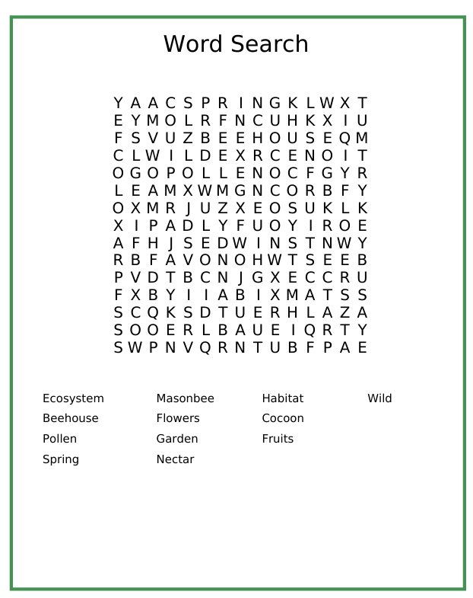

Additional Resources
Am I Even a Bee? by Felicity Muth introduces young readers to the diversity of bees.
Sunshine and Pollen – The Life of a Mason Bee by Monika Grünberg is a beautifully illustrated book that takes readers through the fascinating lifecycle of mason bees, from nest building to pollination,
Buzz: The Nature and Necessity of Bees by Thor Hanson offers a deeper dive into the science and cultural history of bees, suitable for adults and teens.
The Bees in Your Backyard by Joseph S. Wilson and Olivia Messinger Carril is a bee-focused reference guide offering information on identification and ecology.
Mason Bee Revolution: How the Hardest Working Bee Can Save the World – One Backyard at a Time by Dave Hunter explores how mason and leafcutter bees can transform gardens while supporting global pollinator health.
For more books, check out our Storybooks on Pollinators and How Pollinators Shape Our World booklists on Bookshop.org
Crown Bees: www.crownbees.com

Scientific Articles (for facilitators or older participants)
MacIvor, J. S., & Packer, L. (2015). ‘Bee hotels’ as tools for native pollinator conservation: a premature verdict? PLoS One.
Iqani, M., Shilubane, N., & Reynolds, C. (2024). “An Emotional Cycle”: Excitement, Worry, and Joy in a Citizen Science Biodiversity Project Using Bee Hotels. Environmental Communication.

