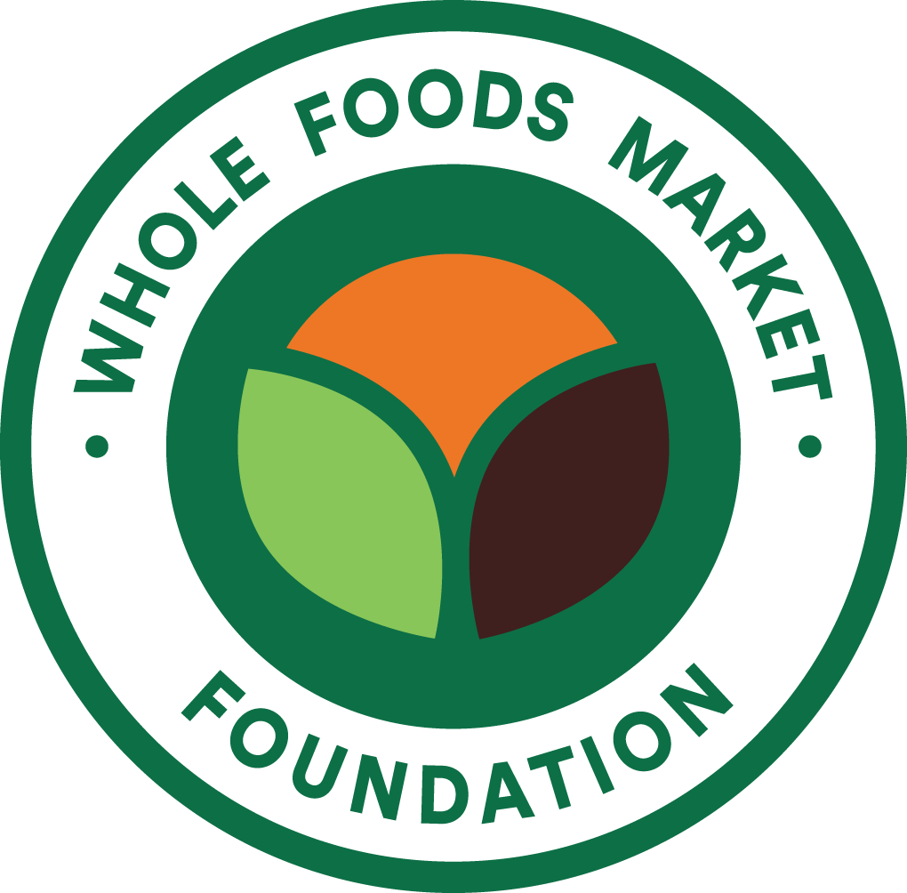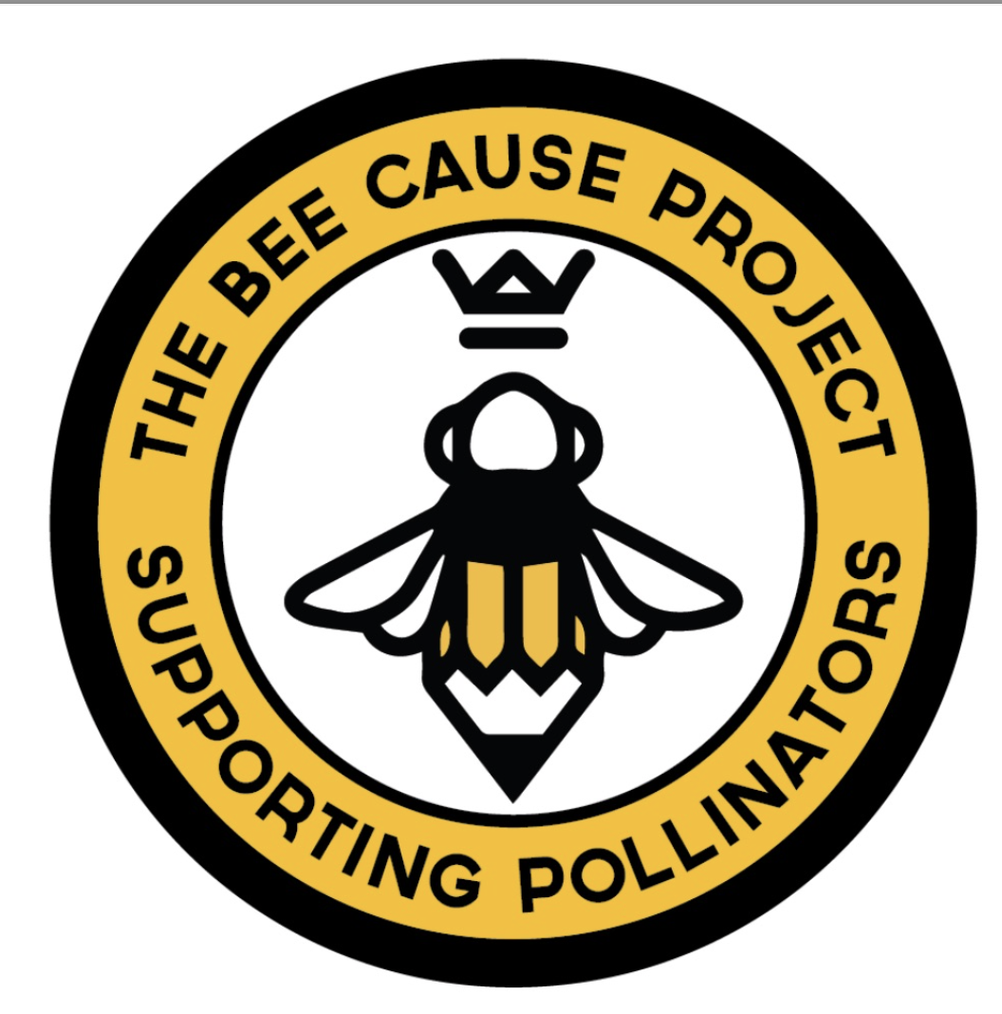

Renewal Bee Grant Program
from The Bee Cause Project and Whole Foods Market Foundation
*This is only a copy of the application questions for your preparation purposes. Applications must be submitted online through our application system SmartSimple, linked here.
The Renewal Bee Grant is offered by Whole Foods Market Foundation in partnership with The Bee Cause Project. The Renewal Grant may be awarded to a school or non-profit organization that has previously received a Bee Grant through this program. While our main goal is to support live bee program education, we understand that may not always be possible. The Renewal Grant exists to grow pollinator programming with or without live bees.
For any questions regarding the Renewal Grant application or if you need support with your pollinator programming, please email The Bee Cause Project at info@thebeecause.org.
For any technical questions or issues regarding your online application, please email Whole Foods Market Foundation at grants@wholekidsfoundation.org.

Grant Details
All Renewal Grants are valued at $2,500 per grant and include:
- Monetary Grant of $2,000 written to the grantee organization.
- Technical Support, Program Development and Remote one-on-one Consultation from The Bee Cause Project.
- Educator Resources: The Bee Cause Resources are designed to guide and support Bee Grant educators through the development and growth of pollinator programming. The activities, lessons, and guides in this educator pack are designed to meet you where you are in your bee programming, whether that is in the classroom, outdoors, or distance learning.
  - Access to The Bee Cause Project Open Educational Resources portal for pollinator resources (https://www.oercommons.org/).
  - Access to The Bee Cause Project website for all curriculum, virtual field trips, book club challenges, and lesson plans.
  - Access to the Inside Buzz Monthly Newsletter and the Bee Grant Buzz Community on Facebook.
TIMELINE:
Application open date: September 1, 2026
Application deadline: October 30, 2026
Notification of all applicants: December 16, 2026
Grant package will arrive by: February 2027
ELIGIBILITY:
- Applicants must have received a Whole Kids / Whole Foods Market Foundation + The Bee Cause Project “Bee Grant” in the 2025 Bee Grant Cycle or earlier and have submitted their progress report. In other words, applicants are required to wait a year in between the last time they were awarded a Bee Grant and applying for the Renewal Bee Grant.
- Applicants are only eligible to apply if they have been awarded less than 2 Renewal Bee Grants.
- Funds and materials must be dedicated to support pollinator programming for students.
- The principal or executive director must be aware of and supportive of the pollinator programs.
- There must be an individual at the school or organization who is the designated “Bee Advocate.” This role serves as the point of contact for pollinator programming.
REQUIRED READING:
Please read through all required reading before submitting your application:
- Renewal Grant Overview
- How to Build Your Bee Club
- Pay It Forward Fundraiser Details
You can find these on The Bee Cause Project’s Resource Page: https://www.thebeecause.org/resources/
APPLICATION PROCESS AND NOTIFICATION:
The application is conducted online. Visit our applicant portal during the application window to access the application: https://wholekidsfoundation.smartsimple.com.
Your application can be saved and completed in multiple sessions. Once it is submitted, the applicant will receive a confirmation email. At this point, the application can no longer be edited.
Applications will be reviewed once the application window has closed on October 15th, 2026. All applicants who submitted an application will be notified no later than December 16th, 2026. Grant packages will be shipped in February 2027.
NEED HELP or HAVE QUESTIONS? Attend our webinars for more information about the application process and best practices on building buzzworthy pollinator programming. If you cannot make it to the webinar, the recordings will be posted after the date listed. Click the link below at the desired time to register.
- Bee Grant Application Webinar #1: ​Tuesday​, September ​8​^{th}, 202​6​ @ 9 AM PDT / 11 AM CDT/ 12 PM EDT: link on website
- Bee Grant Application Webinar #2 w/ Open Q&A: Tuesday, September ​14​th, 202​6​ @ ​2​ PM PDT/ 4 PM CDT/ ​5​ PM EDT: link on website
For any questions regarding the Renewal Grant application or if you need support with your pollinator programming, please email The Bee Cause Project at info@thebeecause.org.
For any technical questions or issues regarding your online application, please email Whole Kids at grants@wholekidsfoundation.org.
**************************************************************

PLEASE NOTE: As a previous Bee Grant Recipient, your school/organization will already be registered in our grant management system.
Please visit the SmartSimple Login Page to sign in or retrieve your password or reach out to grants@wholekidsfoundation.org for support with your account, login, or password.
APPLICATION
Eligibility Questions
- Are you a public or nonprofit private school or a 501(c)(3) non-profit organization (US)/registered charity (CAN) that serves any grades kindergarten through 12th grade? Y/N
  - If no, the applying entity must meet the above criteria.
- Has your school/organization received a Bee Grant in 2025 or earlier from Whole Kids/Whole Foods Market Foundation and The Bee Cause Project? Y/N
  - If no, this Renewal Grant is only available to previous Bee Grant recipients.
Fiscal Sponsor/Grantee
A fiscal sponsor is a separate entity (e.g., a non-profit organization or a school PTO) that can receive the funds on behalf of the applying school or organization for fiscal or programmatic needs. If selected, the grant agreement will be signed by an individual with the fiscal sponsor organization and the grant check will be made out to the fiscal sponsor organization. Having a Fiscal Sponsor is OPTIONAL and NOT required.

- Do you have a Fiscal Sponsor?
- If yes, in what country does your Fiscal Sponsor reside?
  - United States / Canada
- Type in your Fiscal Sponsor name below.
- EIN – Employee Identification Number (US Organizations only) / Charity # (Canadian organizations only – 9-digit bin number + 4-digit RR number)
Fiscal Sponsor Contact Information
- Fiscal Sponsor Primary Contact First Name
- Fiscal Sponsor Primary Contact Last Name
- Fiscal Sponsor Primary Contact Email
- Fiscal Sponsor Primary Contact Phone

PLEASE NOTE - If you have a Fiscal Sponsor, they must also be listed as the Grantee Organization. If you do not have a Fiscal Sponsor, you must include the information for the applying school or organization.
Please provide information for the Grantee Organization to whom the check will be written. Then, identify the individual who will be responsible for signing the Grant Agreement. We do not have a preference for who this individual is. Please list someone at your school, organization, or Fiscal Sponsor entity who has the ability to sign formal documents.
- Grantee Organization (This is the organization to whom the grant check will be made out)
- Grantee Organization Street Address
- Grantee Organization City
- Grantee Organization State/Province
- Grantee Organization Zip/Postal Code
- Grantee Signee Name (This is who will sign the grant agreement)
- Grantee Signee Title
- Grantee Signee Email

Application Questions
Please note: The Renewal Grant does not require live bees. If you plan to use this grant to have live bees return to your campus, we highly advise receiving approval for the bees before you submit this application. Some states, counties, and/or school districts require a more extensive approval process. This is particularly important when it comes to approval from insurance providers.
Program Details
- Does your school or organization currently host a beehive? Y/N
  - If yes, please describe how the beehive is managed, including who manages the hive and how often.
  - If yes, in the case of potential distance learning or time away from campus, how are you managing your hive during extended periods away and/or summer vacation?
  - If no, do you intend to use the resources in this Renewal Grant to host a hive (part-time or full-time) in the near future?
- Please share any complementary bee education or pollinator education that your school or organization engages in, either with or without a beehive.
- Whether you have a hive or not, how many children are you currently engaging in your bee education programming?
- Whether you have a hive or not, how many teachers at your school or educators at your organization engage their children in bee education?
- If the grant is awarded, does the educator(s) have a plan to provide equally effective alternate access to the bee curriculum and/or any bee programming to all intended students within the school or organization?
- Please share how your community is involved with your bee program, if at all.

Required Reading
Please read through each of the below resources before submitting your application:
- The Renewal Grant Overview
- How to Start + Grow Your Bee Program
- Pay-It-Forward Fundraiser Details
You can also find them on The Bee Cause Project’s Resource Page: https://www.thebeecause.org/resources/
- Have you read through the suggested reading: The Renewal Grant Overview, How to Start + Grow Your Bee Program, Pay-It-Forward Fundraiser Details? Y/N
Hive Support Details
- What is your goal for this program and how will the Renewal Grant help reach this goal? Please include how your program has developed from when you last received your Whole Kids/Whole Foods Market Foundation and The Bee Cause Project Bee Grant.
- What lessons did you learn from your initial Bee Grant that you will be applying to your program moving forward? Is there anything you plan to do differently?
- Bee Advocate details: Who will be the designated Bee Advocate at your school or organization
  - First Name
  - Last Name
  - Email
  - Phone Number
  - Relationship to the school or organization
Delivery Information
- Please check below to confirm you are aware that, if awarded, this grant will be shipped as one shipment.
  - I am aware that if awarded, I will receive one shipment with my grant materials.
- Shipping Address: All shipments will be shipped to the same address based on the information provided below. Please provide an address that can receive deliveries at all times if your school or organization will possibly be closed at the time of shipment (February 2027). Shipments can be sent to a home/residential address if necessary, but not to a P.O. Box.
  - Street Address
  - City
  - State or Province
  - Zip/Postal Code
  - Country
  - Additional delivery instructions, if applicable
- Please provide information for an individual that can be contacted related to shipping and delivery of your grant.
  - Shipping Contact First and Last Name
  - Shipping Contact Phone Number
  - Shipping Contact Email
Budget/Intention
- Monetary funds cannot be used for real estate, travel costs, or field trips. Any funds spent on a scholarship, such as to attend a training, may not exceed 40%. Please check that you agree to our budgetary restrictions.
  - (Please check) I agree to these budgetary guidelines.
- Renewal Grant Budget: Please provide a budget for how you intend to spend the monetary funds you receive. If you need guidance, please refer to The Renewal Grant Overview document for more ideas on how to best utilize the grant funds to support your program. (Budget items and costs will be entered into a table format in online application).
Thank you for applying to the Renewal Bee Grant! All applicants will be notified on December 16th, 2026. We look forward to reviewing your application.
We are here to help you adapt your program wherever it may be this year. On The Bee Cause’s resources page, you will find a few of the pollinator resources, activities, and core compliant lesson plans. These activities are great with or without live bees!
Find more resources at https://www.wholefoodsmarketfoundation.org/our-work/childrens-nutrition/bee-grant/bee-program
For any questions regarding the Renewal Grant application or if you need support in growing your pollinator programming, please email The Bee Cause Project at info@thebeecause.org.
For any technical questions or issues regarding your online application, please email Whole Foods Market Foundation at grants@wholekidsfoundation.org.

